New Delhi, India

July 31, 2024

BUSINESS REquirement DOCUMENT (BRD)

*GEG MIS Expansion*

**Revision History**

|  |  |  |  |
| --- | --- | --- | --- |
| Name | Date | Reasons of Changes | Version |
| iTM | 31 July 2024 | The first draft of BRD developed. | V1 |

Table of Contents

Overview 3

Project Background 3

Functional Requirements 4

BR 1 Pre-Registration 5

BR 1.1 – Update Name 5

BR 2 - Registration 6

BR 2.1 – Verify NIN, Approve Registration and update NSR 6

BR 2.2 – Beneficiary profile update 8

BR 2.3 – Exit beneficiary from the cycle 15

BR 2.4 – Assigning specific grievance to specific user 16

BR 2.5 – Mentoring 16

BR 3 At a Glance 18

BR 3.1 Quick access to open grievances 18

BR 4 Generate Report 18

BR 4.1 Generation of reports and statistics 18

BR 5 Admin 19

BR 5.1 Cohort 19

BR 5.2 Master Lists 22

# Overview

The purpose of this Business Requirements Document (BRD) is to outline the requirements for the expansion of the existing Girls Empowering Girls (GEG) Management Information System (MIS). This document will serve as a guide for the project team to ensure that all business needs are met effectively.

This document clearly articulates the goals and objectives of the MIS system expansion and define the boundaries and scope of the project to ensure all stakeholders have a mutual understanding of what is to be achieved. It captures and document the specific business requirements that the expanded MIS must fulfill to ensure that all functional and non-functional requirements are identified and understood.

This will be a foundational document that guides the design, development, and implementation phases of the MIS expansion and to ensure that the development team has a clear understanding of the business needs and technical specifications. It will act as a communication tool among various stakeholders including Kampala Capital City Authority (KCCA), Ministry of Gender (MoGD), UNICEF Uganda and other partners.

# Project Background

The GEG MIS is a web-based software platform that was developed by KCCA in partnership with UNICEF Uganda for "Girls Empowering Girls" (GEG) program. The system ensured all the project information is brought together to facilitate real time monitoring and reporting. The system encompasses the registration, verification, and management of beneficiaries, creation, modification, and tracking of social protection programs, automated disbursement and reconciliation of cash transfers, coordination and tracking of additional services provided alongside cash transfers and generation of reports and analytics to support decision-making.

The system offers several advantages, particularly with an aim at managing and serving beneficiaries and their services efficiently. The system supports consolidation of all relevant data related to beneficiaries in a central repository. This includes demographic information, eligibility criteria, program enrollment status, service including cash transfers usage history, and any other pertinent details. Having all this information in one place facilitates efficient management and analysis.

This system provides support to manage the data of in school girls (ISG) and out-of-school girls (OOSG) living in Kampala, manage a network of peer and lead mentors and cash transfer information to ensure, all project information, which has been collected and managed offline, in different places, is brought together to facilitate real time monitoring and reporting on the project for better decision making on GEG programme.

Building on the success of the GEG MIS platform, there was a need to expand its current features to accommodate growth and improve operational efficiency. The expansion will address current limitations and incorporate new functionalities to better support the organization's strategic goals.

Below sections explains the detailed functional requirement of each module of the GEG MIS expansion.

# Functional Requirements

The platform comprises of modules to perform the MIS operations. Below is the list of all the modules -

1. Home Page
2. About
3. Information Kiosk
4. Login
   1. Pre-registration
   2. Beneficiary
      1. Profile
      2. Cash Transfer
      3. Mentoring
      4. Referral
      5. Grievance / Complaint
   3. Admin
      1. Cohort
      2. Area
      3. User
      4. Resource
      5. Master List
      6. Log
      7. Audit Trail
   4. Reports

The detailed functional requirements are explained below that will meet the requirements of expanding the functionalities of the MIS.

## BR 1 Pre-Registration

### BR 1.1 – Update Name

**Requirements**

Separation of beneficiary names (First name, Surname, Other name)

**Functional Requirements**

|  |  |
| --- | --- |
| BR 1.1.1 | * **First Name** of the girlshould be entered and cannot be blank. * **Last Name** of the girlshould be entered and cannot be blank. * **Other Name** of the girlshould be entered. |

## BR 2 - Registration

### BR 2.1 – Verify NIN, Approve Registration and update NSR

**Requirements**

NIN will be verified against the National Registry

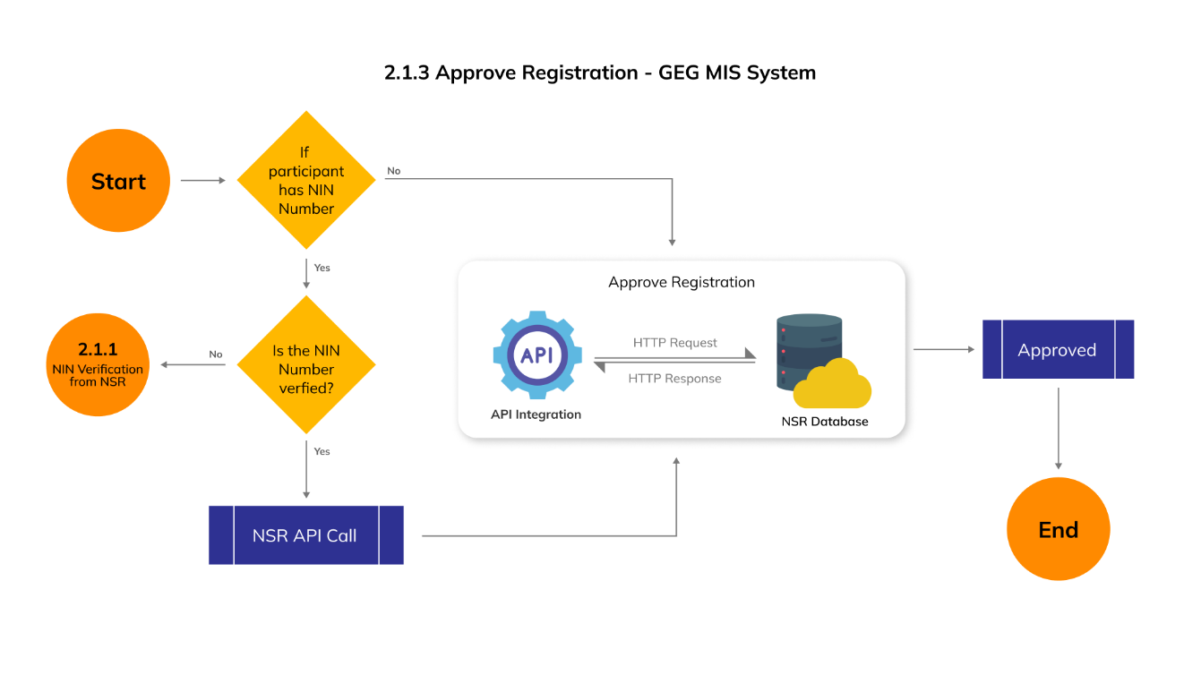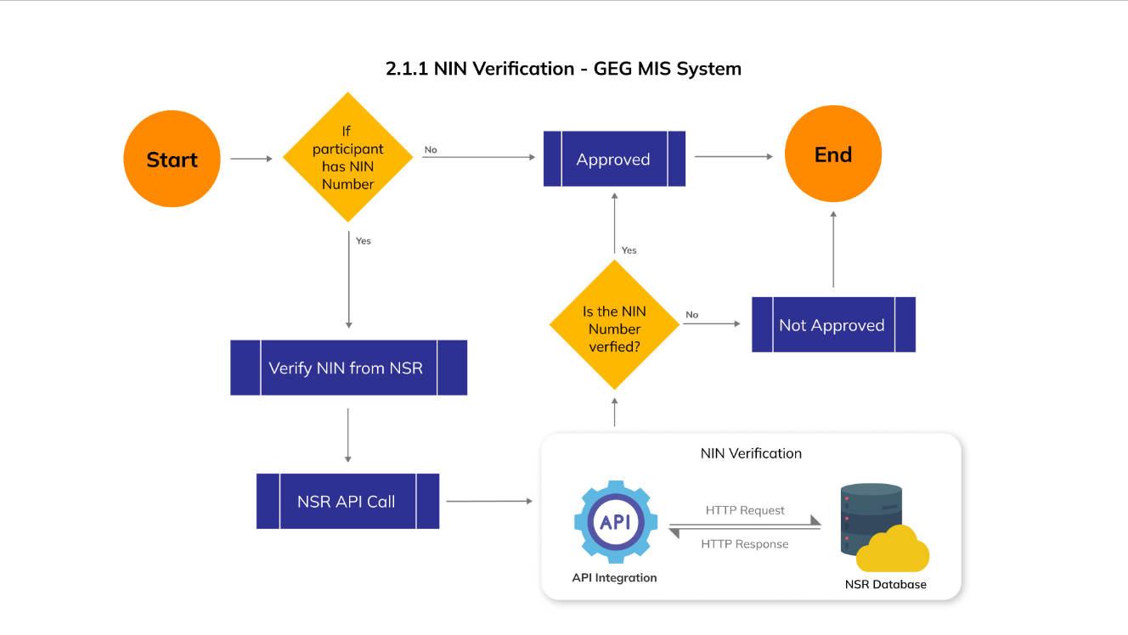**Process Flow Diagrams**

**Functional Requirements**

|  |  |
| --- | --- |
| BR 2.1.1 | Provide the option to **Verify NIN** in the pending list under action column of each participant with the following validations –   * The Verify NIN option should be disabled for the participant who do not have an NIN number. * Verify ID, First Name, Last Name and Other Name (if exist) from NSR registry API when clicked on Verify NIN. * Show message on the successful or failed verification of NIN. |
| BR 2.1.2 | Provide a column **NIN Status** in the table grid of pending list that will show the verification status of the NIN of each participant. |
| BR 2.1.3 | Provide an option to **Approve** in the action dropdown of the participants with following validations –   * The Approve option will be disabled for the participants whose NIN exist but is not verified. * The Approve option will be enabled for the participants whose NIN does not exist. * The Approve option will be enabled for the participants whose NIN exist and is verified. |
| BR 2.1.4 | If approved, move the participant to approve list from pending and allow performing following action in the Approved state –   * Edit * Exit |

### BR 2.2 – Beneficiary profile update

**Requirements**

Ability to update a beneficiary profile

* Back to school for OOSG and the schools joined
* Transition to secondary school and the schools joined for both ISG and OOSG who have rejoined school. For those not transitioned, capture reason
* PLE results for those that are in school
* OOSG undertaking skilling (Digital, Life skills, Foundational literacy and numeracy skills and I-Upshift, Bakery and cookery, Fashion and design, Leather designing, Electronics, Plumbing, Carpentry). Capture completion of training whether YES or NO and comment completion of training whether YES or NO and comment
* OOSG doing business and to specify the kind of business by comment
* Teenage pregnancy

Cash transfer (Tagging of profiles to CT amounts)

* Linking the disability status of a beneficiary to cash transfer to include the 50% top-up for those that are disabled
* The changes in the cash transfer amount to a beneficiary could be based on the “Transition to Secondary school” status other than originally discussed (year three for all ISG). We note that not all ISG transition in year 3 and that there are some OOSG who go back to school and transition to secondary school.

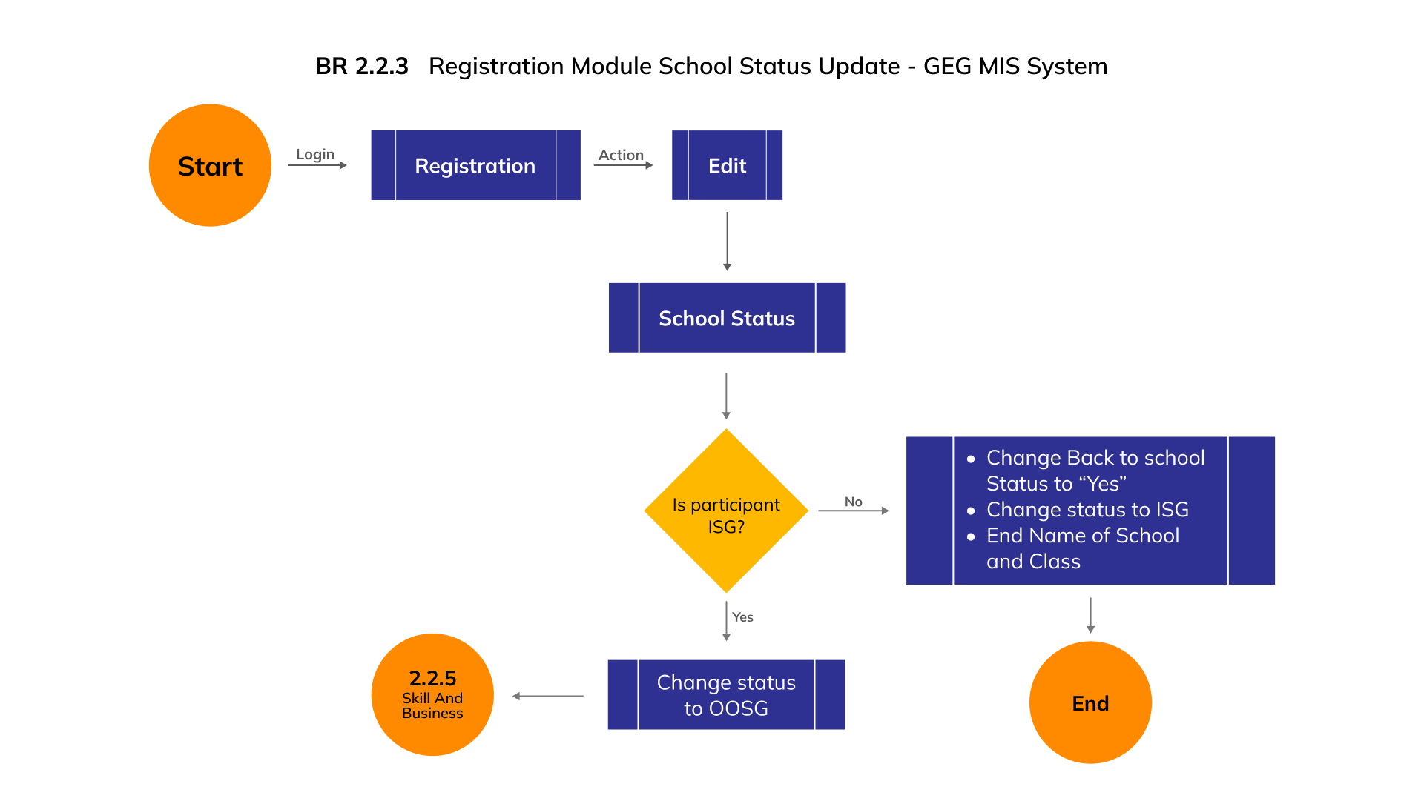**Process Flow Diagrams**

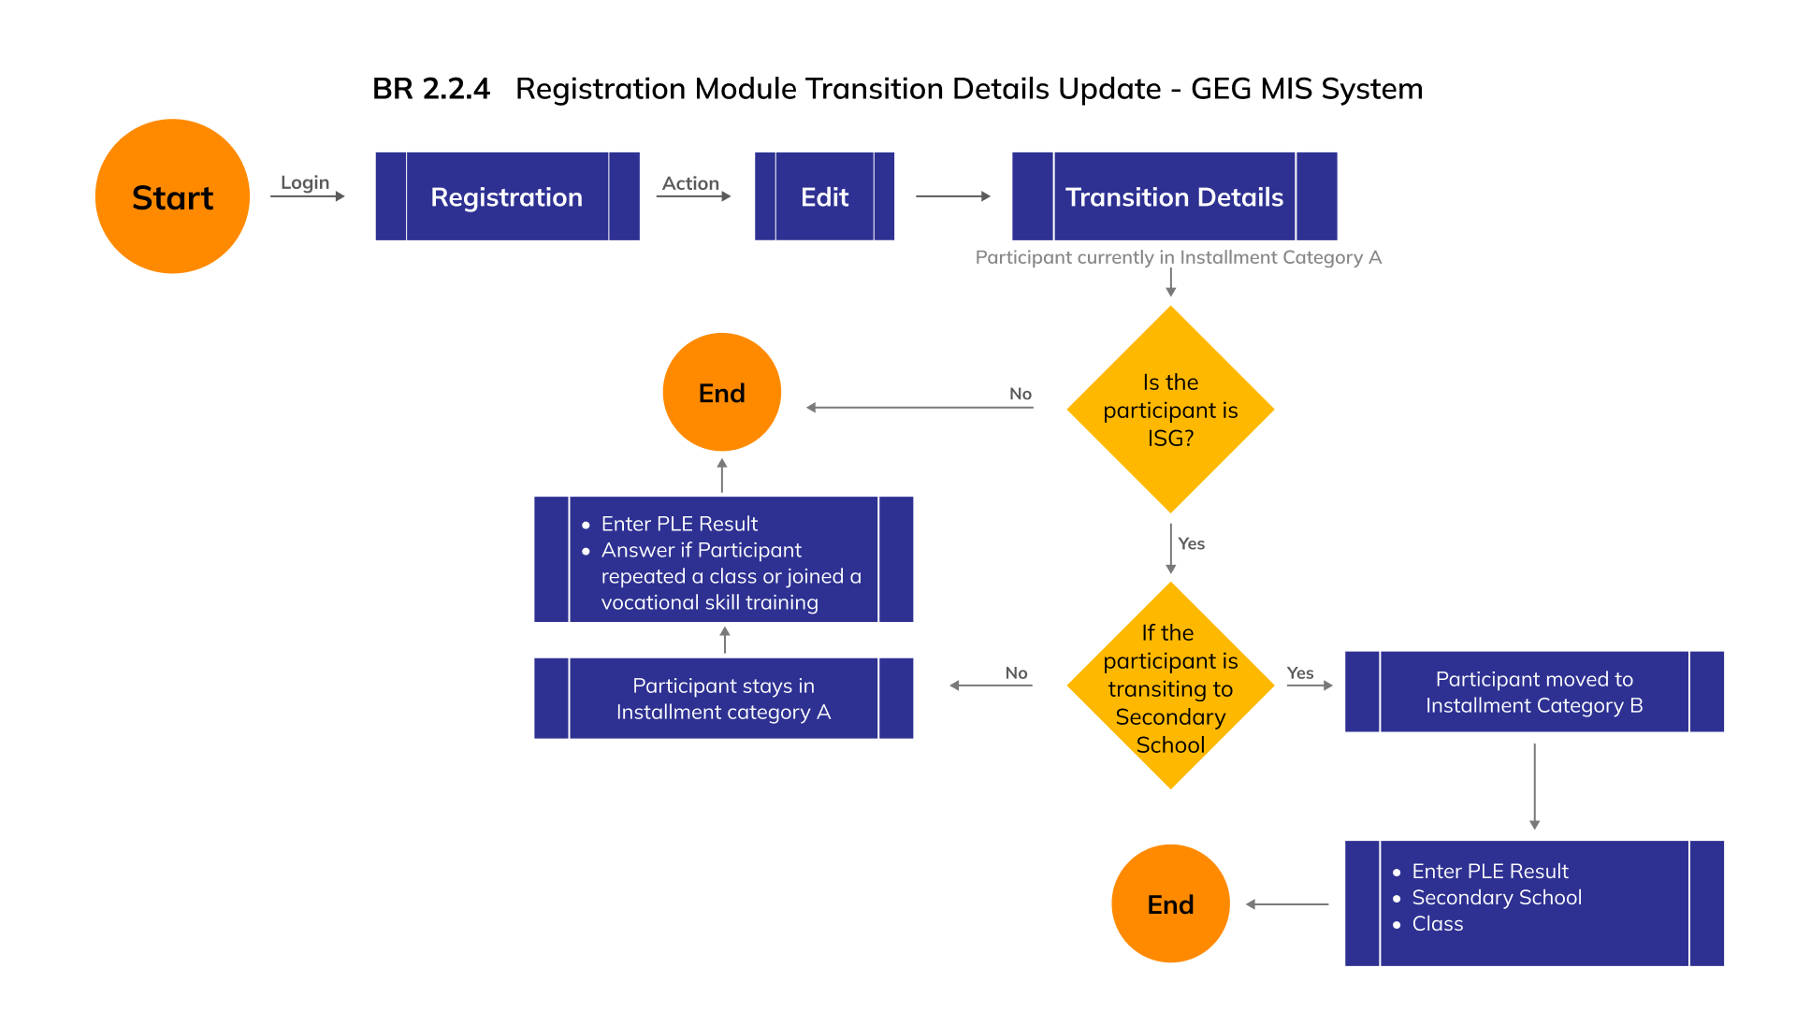

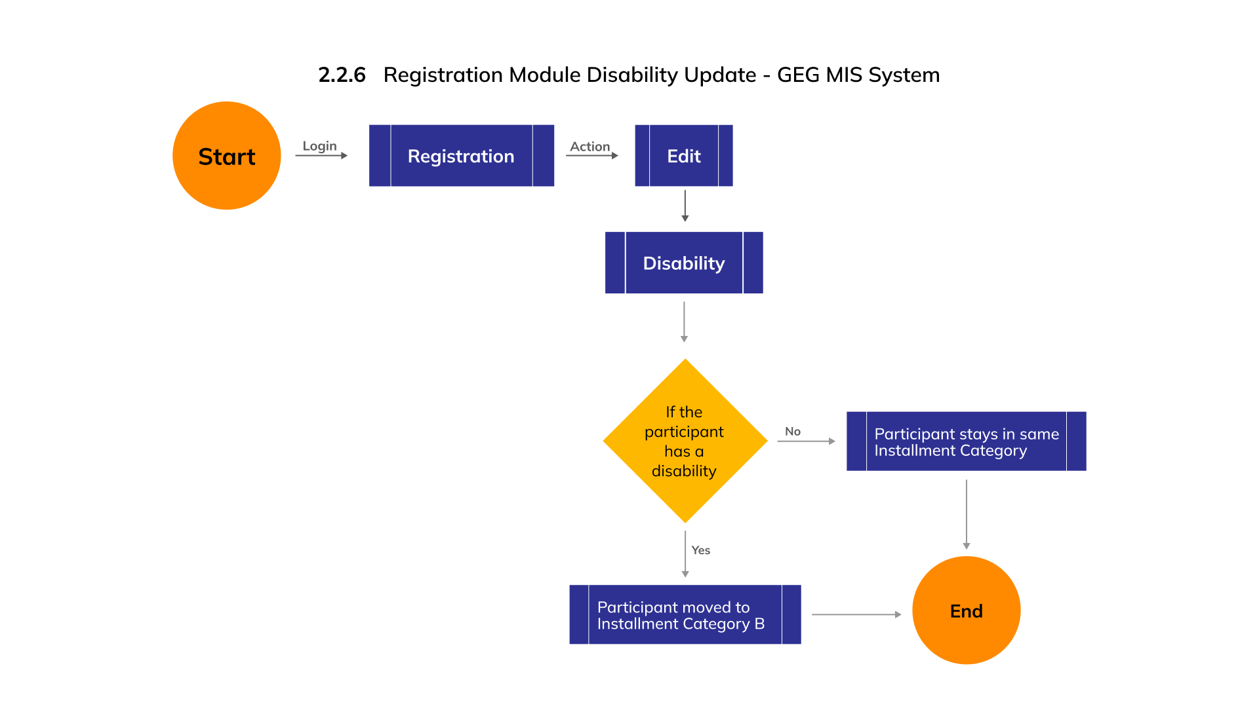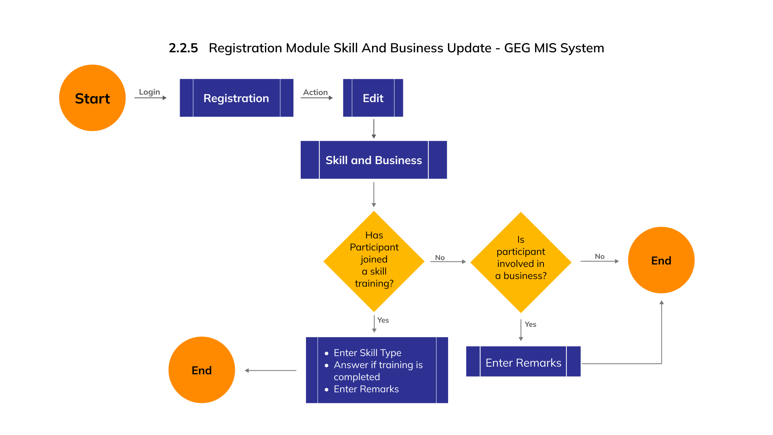

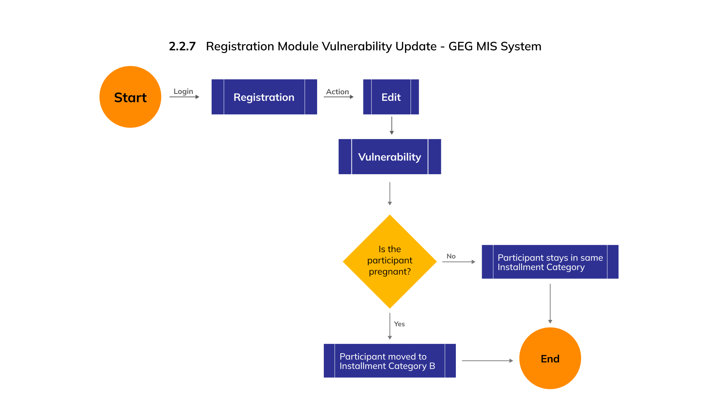

**Functional Requirements**

|  |  |
| --- | --- |
| BR 2.2.1 | Provide an **Edit** option in the approved list under action column of each participant. |
| BR 2.2.2 | When editing the participant, provide a dropdown to select one of the following categories -   * School Status * Transition Details * Skill and Business * Disability * Vulnerability * Participant Personal Details * Caretaker Details |
| BR 2.2.3 | When editing **School Status**, provide the following entries and validations -  **In case of ISG -**   * Provide an **Education Category** dropdown with options - In School and Out of School. * By default, show **In school** option selected in the Education Category dropdown. * Allow updating school status from "In School" to "Out of school”   **In case of OOSG -**   * Provide an **Education Category** dropdown with options - In School and Out of School. * By default, show **Out of School** option selected in the Education Category dropdown. * Provide a dropdown to select **Back to school** status as either Yes or No. * Update the school status from "Out of school" to "In School". (*If the Back-to-School option is selected as Yes*) * Provide option to Select Division and it cannot be blank. * Provide option to Select School it cannot be blank. * Provide option to Select Class it cannot be blank.   Provide an **Update** button to save the changes. |
| BR 2.2.4 | When editing **Transition Status**, provide the following entries and validations -  **In case of ISG -**   * Provide a dropdown to select Transition Status as either Yes or No. * *In case the Transition status is YES -* * Provide a textbox to enter PLE Results and it cannot be blank. * Provide a dropdown to select Secondary School and it cannot be blank. * Provide a textbox to enter Class name and it cannot be blank. * *In case the Transition status is NO -* * Provide a textbox to enter PLE Results and it cannot be blank. * Provide a radio button to select if participant has **Repeated a class** or **Joined a vocational skill training.**   **In case of OOSG –**   * Disable the **Transition Status** option in the dropdown.   Provide an **Update** button to save the changes. |
| BR 2.2.5 | When editing **Skill and Business,** provide the following entries and validations –  **In case of OOSG -**   * Provide a **Skill** dropdown with option as Yes and No to confirm taking up a Skill. * When Skill is selected as Yes - * Provide an option to select **Skill Type** and it cannot be blank. * Provide a **Training** dropdown with option as Yes and No to confirm if the training is Completed and it cannot be blank. * Provide option to enter Remarks. * Provide a **Plus** button to select multiple skill type and allow adding respective training details. * When Skill is selected as No - * Provide a **Business** dropdown with option as Yes and No to confirm taking up Business. * Provide option to enter Remarks (If Business is selected as Yes).   **In case of OOSG -**   * Disable the **Skill and Business** option in the dropdown.   Provide an **Update** button to save the changes. |
| BR 2.2.6 | When editing **Disability Status** provide the following entries and validations -   * Provide a **Disability** dropdown with option as Yes and No. Allow selecting one of the option to confirm if the participant has any disability. * 50 % top up should be given if the disability status is selected as **Yes**.   Provide an **Update** button to save the changes. |
| BR 2.2.7 | When editing **Vulnerability Status**, provide the following entries and validations -   * Provide a **Teenage pregnancy** dropdown with option as Yes and No. Allow selecting one of the options to confirm if the participant has teenage pregnancy. * 50 % top up should be given if the teenage pregnancy is selected as Yes.   Provide an **Update** button to save the changes. |
| BR 2.2.8 | When editing **Participant** **details**, provide the following entries and validations -   * Provide option to update **NIN** and **Address** of the participant. * When updating the NIN, provide a **Verify** button to verify the updated NIN with NSR.   Provide an **Update** button to save the changes. |
| BR 2.2.9 | When editing **Caretaker details**, provide the following entries and validations -   * Provide option to update **NIN** and **Address** of the caretaker. * When updating the NIN, provide a **Verify** button to verify the updated NIN with NSR.   Provide an **Update** button to save the changes. |

### BR 2.3 – Exit beneficiary from the cycle

**Requirements**

Exit a beneficiary from the cycle

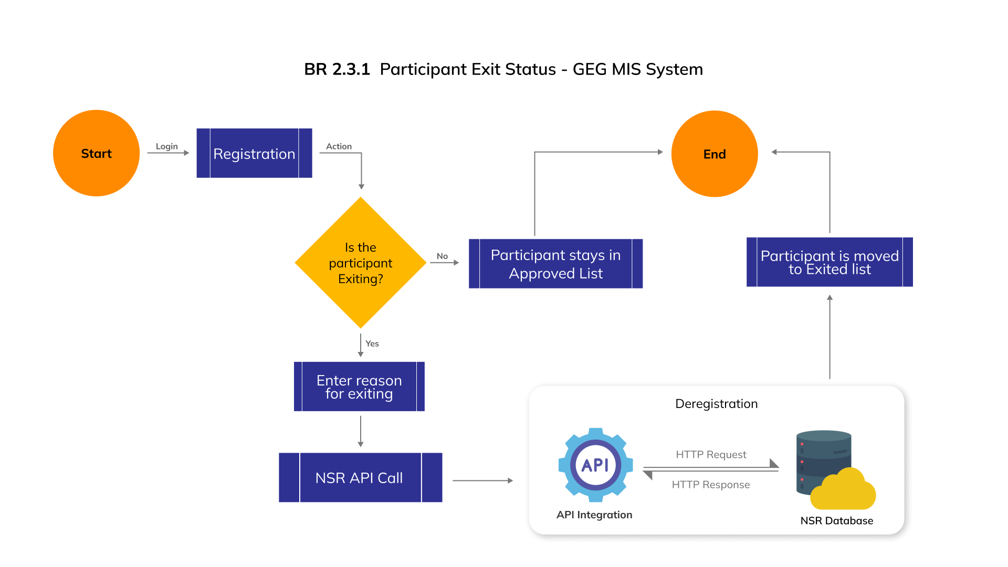**Process Flow Diagrams**

**Functional Requirements**

|  |  |
| --- | --- |
| BR 2.3.1 | Provide **Exit** option in the Approved list under action dropdown to move theparticipant to Exit list from Approved.   * When exiting participant provide an option to select **Reason of Exit**. |

### BR 2.4 – Assigning specific grievance to specific user

**Requirements**

Possibility of channeling specific grievances to specific user.

**Process Flow Diagram**

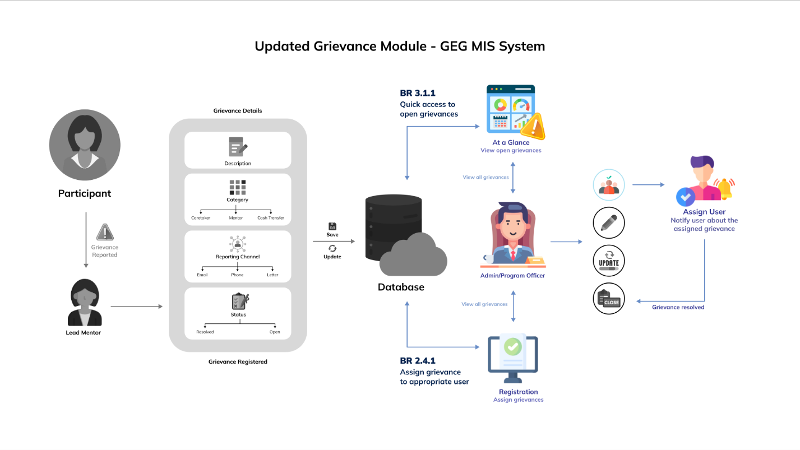

**Functional Requirements**

|  |  |
| --- | --- |
| BR 2.4.1 | Allow **Admin** and **Program Officer** to view grievances of all the participants. |
| BR 2.4.2 | Provide Admin and Program Officer to assign a specific user to the grievance when adding or updating a grievance. |

### BR 2.5 – Mentoring

**Requirements**

Making data entry across the different modules easier by creating a calendar access to a period of interest (month and year) other that scrolling through all the periods over and over again

**Functional Requirements**

|  |  |
| --- | --- |
| BR 2.5.1 | In Mentoring popup window, provide option to **Select Year** and **Select Month**. |
| BR 2.5.2 | The mentoring session of selected time period should be displayed. |

## BR 3 At a Glance

### BR 3.1 Quick access to open grievances

**Requirements**

Creation of a quick access to open grievances.

**Functional Requirements**

|  |  |
| --- | --- |
| BR 3.1.1 | Provide the count of **Registered**, **Closed** and **Open** grievances when clicking on the table icon available at the top right corner of the grievance widget. |
| BR 3.1.2 | Provide an option to **View Open Grievances** by participant and allow admin and program officer to assign user to the specific grievance. |

## BR 4 Generate Report

### BR 4.1 Generation of reports and statistics

**Requirements**

Ability to generate statistics on the following

* OOSG back to school
* Beneficiaries transitioned to secondary school
* Beneficiaries with disability
* Teenage pregnancy
* OOSG undertaking/ completed a type of skilling
* OOSG in business

Identify services accessed by a beneficiary

Ability to generate statistics (on at a glance page) on key program components for shorter periods of time. Its currently only annual. We could add a calendar to allow for free selection of a range of period for which a user needs to see the statistics. It could be a week, month, quarter or annual

Access to report generation or download by Partners and lead mentors

**Functional Requirements**

|  |  |
| --- | --- |
| BR 4.1.1 | Provide option to select one of the report types -   * Registration * Cash Transfer * Mentoring * Referral * Grievance |
| BR 4.1.2 | Allow to perform following settings to generate required report –   * Report **From** and **To** Date should be selected. * Report **Name** should be entered and it cannot be blank. * **Education Category** should be selected. * **Skill** should be selected *(Incase school category is Out of School).* * **Business** should be selected *(Incase school category is Out of School).* * **Transition to Secondary School** should be selected. * **Disability** should be selected. * **Division** should be selected. * **Parish** should be selected. * **Village** should be selected. * **School** should be selected. * Participant **Status** should be selected. |

## BR 5 Admin

### BR 5.1 Cohort

**Requirements**

Cash transfer (Tagging of profiles to CT amounts)

* The changes in the cash transfer amount to a beneficiary could be based on the “Transition to Secondary school” status other than originally discussed (year three for all ISG). We note that not all ISG transition in year 3 and that there are some OOSG who go back to school and transition to secondary school.
* Identify the number of payment cycles of beneficiary

**Functional Requirements**

|  |  |
| --- | --- |
| BR 5.1.1 | Show the existing list of Cohort in tab view with following tab names -Pending, In-progress and completed. Show the list in table grid by pages and provide option to set the number of records per page. |
| BR 5.1.2 | Provide options to search, sort and navigate the existing list. |
| BR 5.1.3 | Provide options to add and edit a cohort and its details in pending and in-progress state. |
| BR 5.1.4 | Provide option to delete a cohort and its details with following validations:   * Show the count of associated records and ask the user to confirm deletion. * Delete all the associated records after confirmation. |
| BR 5.1.5 | Provide option to show/hide a cohort and its details with following validations:   * Show/Hide the cohort and its details in both the applications. * Show/Hide all the associated records. * Do not allow data entry and data import for the hidden cohort. |
| BR 5.1.6 | Allow adding a new cohort and its details with the following validations -   * **Area** should be selected and it cannot be blank. * **Name** should be entered and it cannot be blank. * **Description** of Cohort should be entered. * **Start** **Year** should be selected and it cannot be blank. * **Last** **Date** of Registration should be entered and it cannot be blank. * Provide option to enter **Participant Details** (A popup window should open when clicked on participant details popup).   In participant details popup window, provide the following entries and validations -   * **Number of ISG registration** should be entered it and cannot be blank. * Installments amount of **First Year ISG participants** should be entered. * Installments amount of **Second Year ISG participants** should be entered. * Installments amount of **Third Year ISG participants** should be entered. * **Number of OOSG registration** should be entered it and cannot be blank. * Installments amount of **First Year OOSG participants** should be entered. * Installments amount of **Second Year OOSG participants** should be entered. * Installments amount of Third Year OOSG **participants** should be entered. |
| BR 5.1.7 | Total Planned cost of cohort should be auto calculated based on participant installment amount details. |
| BR 5.1.8 | Provide an Add button to confirm adding a new cohort and its details |
| BR 5.1.9 | Provide option to mark a pending cohort as Approve. |
| BR 5.1.10 | Provide option to mark a in progress cohort as Complete. |
| BR 5.1.11 | The registration of participants should only be allowed when the cohort is in In progress state. |

### BR 5.2 Master Lists

**Requirements**

* OOSG undertaking skilling (Digital, Life skills, Foundational literacy and numeracy skills and I-Upshift, Bakery and cookery, Fashion and design, Leather designing, Electronics, Plumbing, Carpentry). Capture completion of training whether YES or NO and comment completion of training whether YES or NO and comment
* OOSG doing business and to specify the kind of business by comment

**Functional Requirements**

|  |  |
| --- | --- |
| BR 1.5.1 | Add following options to Manage Master List dropdown and allow selecting them –   * Skill * Business |
| BR 1.5.2 | Show the existing list of records and related information in a tabular grid based on the selected master list. Provide option to view the list by pages along with pagination option to customize the view. |
| BR 1.5.3 | Provide options to search, sort and navigate the selected master list. |
| BR 1.5.4 | Provide options to add and edit element to each master list. |
| BR 1.5.5 | Allow adding a new record in selected master list and its details with the following validations:  *In case adding a new record under* ***Skill*** *master list, Provide the following entries and validations –*   * Provide option to enter new *skill*. * No duplicate *relationship* should be added.   *In case adding a new record under* ***Business*** *master list, Provide the following entries and validations –*   * Provide option to enter new *business*. * No duplicate *relationship* should be added. |
| BR 1.5.6 | Provide the Add button in the add new element window to confirm adding the element. |

**\*\* END OF THE DOCUMENT \*\***